**Exercise for Introduction to Databases**

**1.Create Database:**

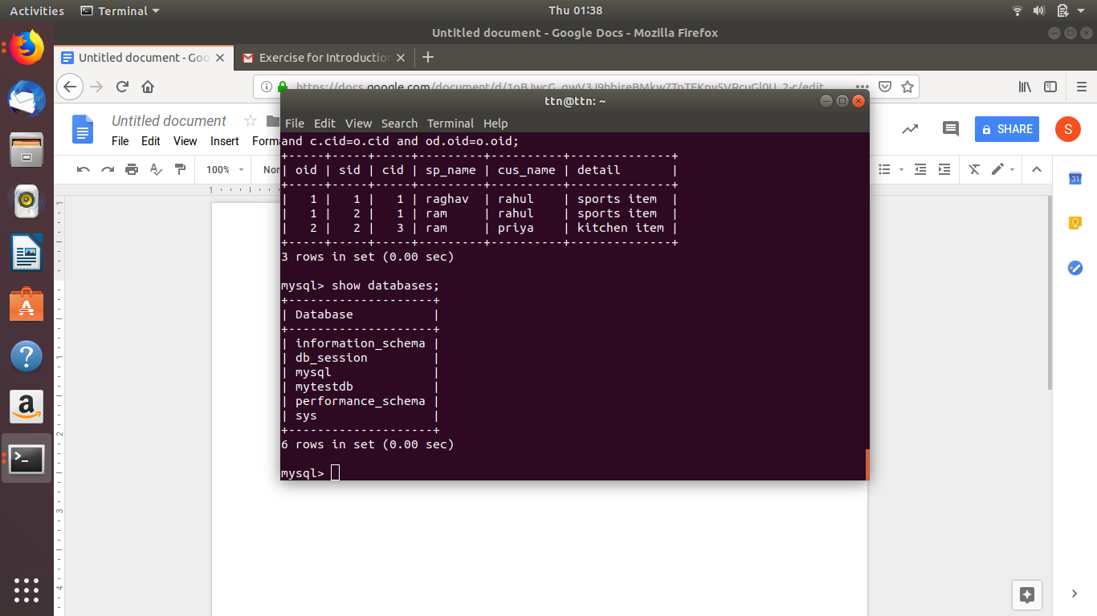

In this our database is **mytestdb.**

**2.Design schema**

1)Customer(cid(pk),cus_name,cemail,phone,date_created).

2)orders(oid(pk),cid(foreign key to customer(cid)),detail,date_created).

3)salesperson(speid(pk),sp_name,sp_email,date_created).

4)order_for_salesperson(**oid**(foreign key to orders(oid)),**sid**(foreign key to salesperson(speid)),**cid**(foreign key to customer(cid)),date_created).

**3.create tables**

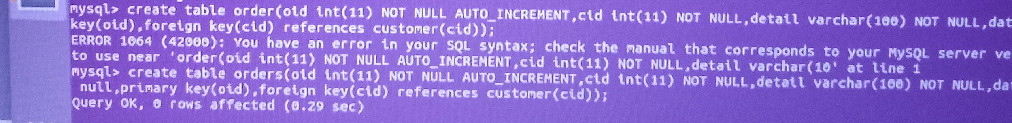

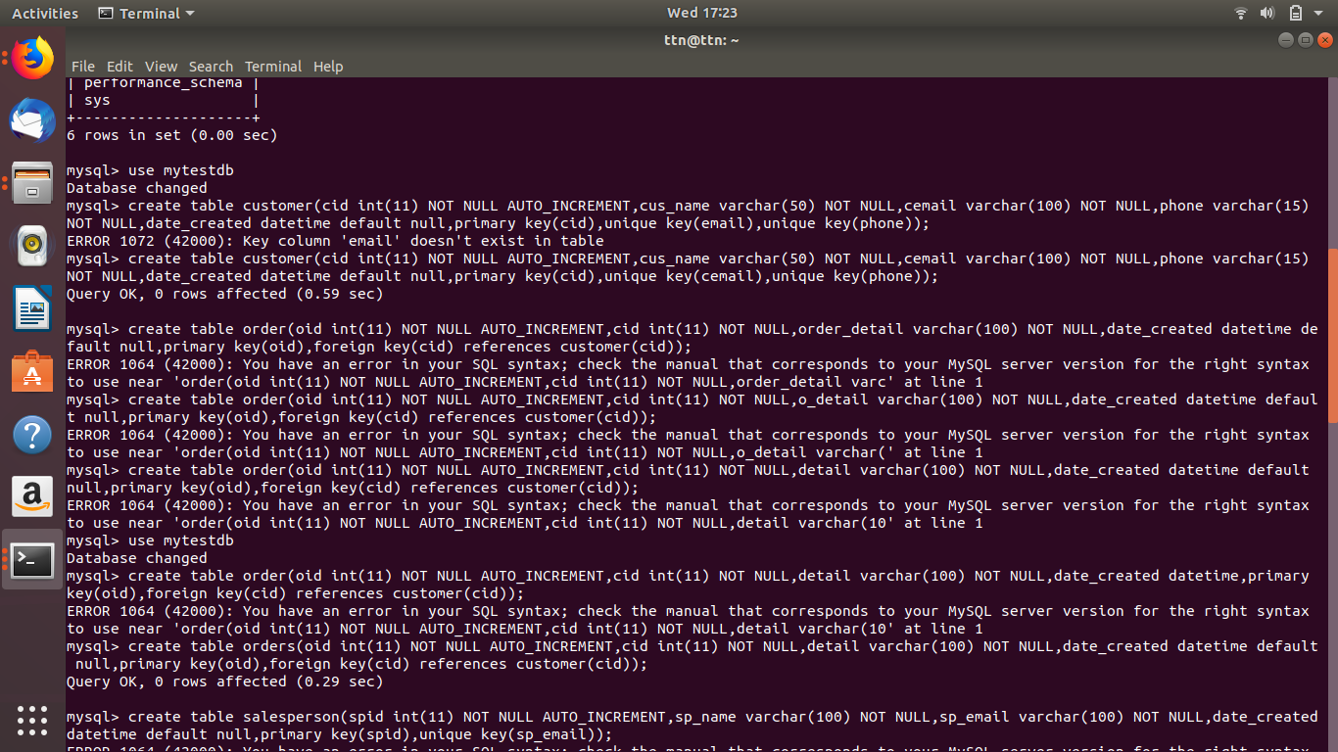

**(full screen picture)**

**4.Insert sample data**

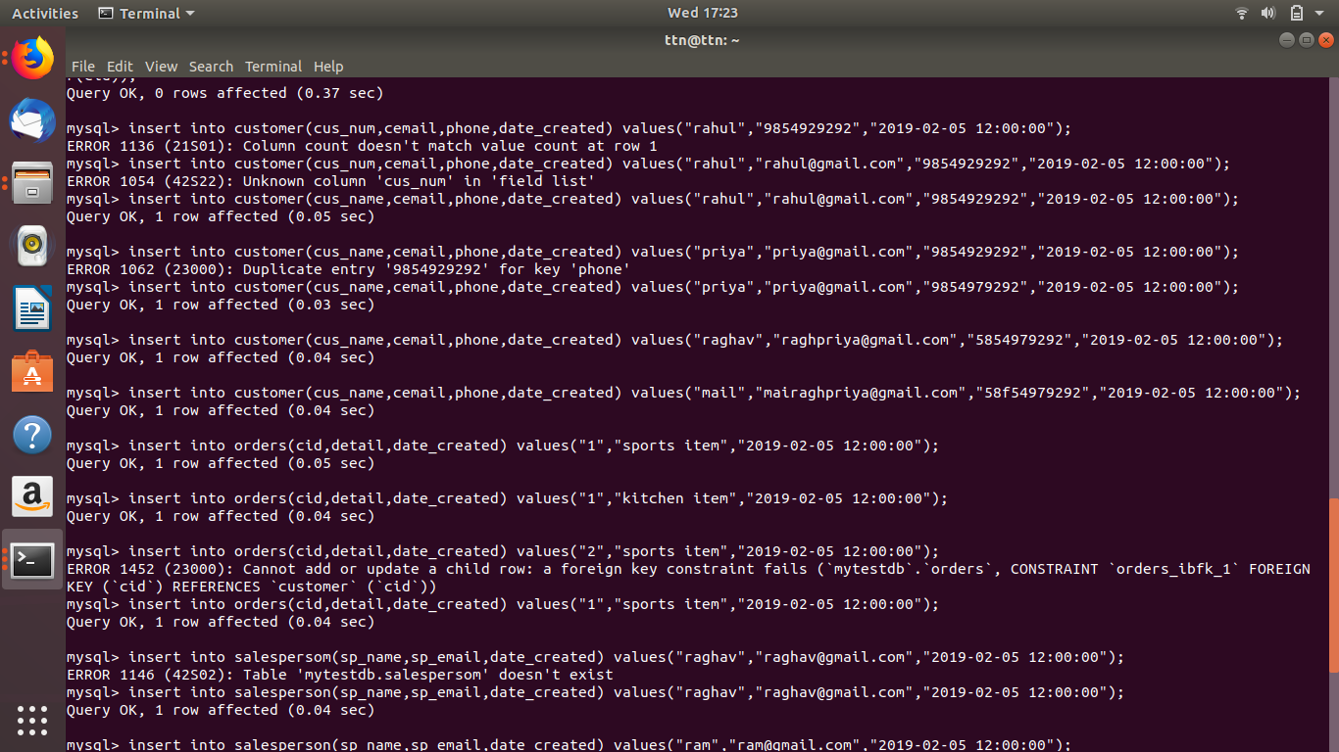

**5.Find the sales person have multiple orders.**

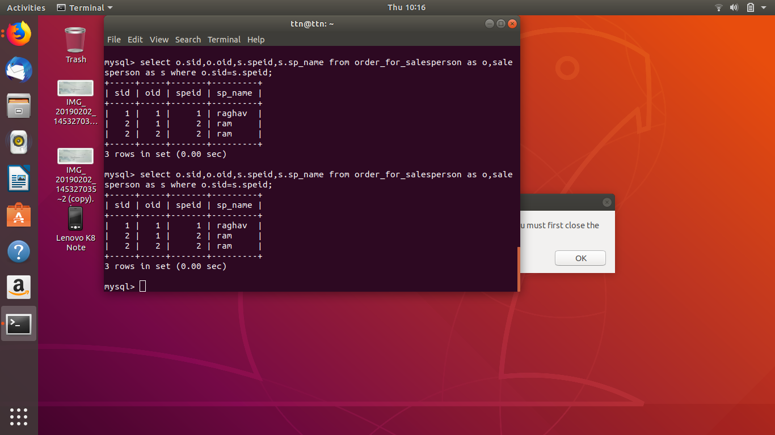

**6.Find the all sales person details along with order details**

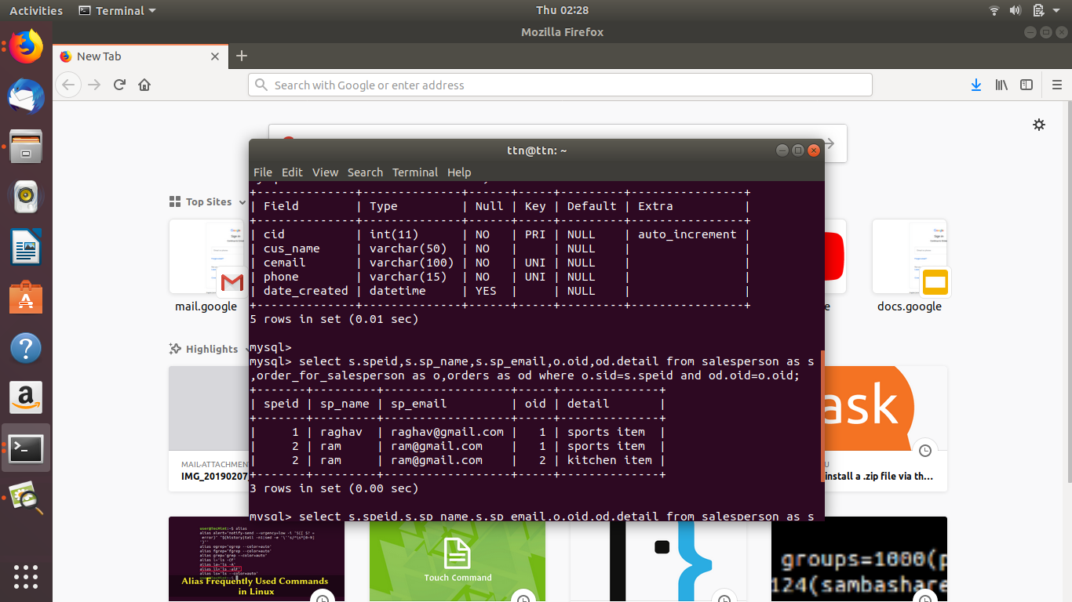

**select s.speid,s.sp_name,s.sp_email,o.oid,od.detail from salesperson as s,order_for_salesperson as o,orders as od where o.sid=s.speid and od.oid=o.oid;**

**7.Create index**

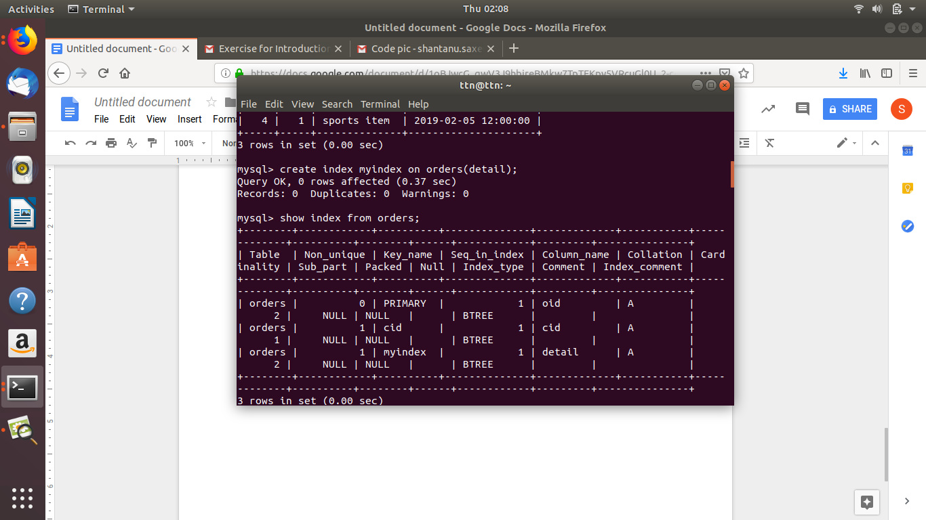

**//to create index**

**Create index myindexon orders(detail);**

**8.How to show index on a table**



**//to show index on table**

**Show index from orders**

**9.Find the order number, sale person name, along with the customer to whom that order belongs to**

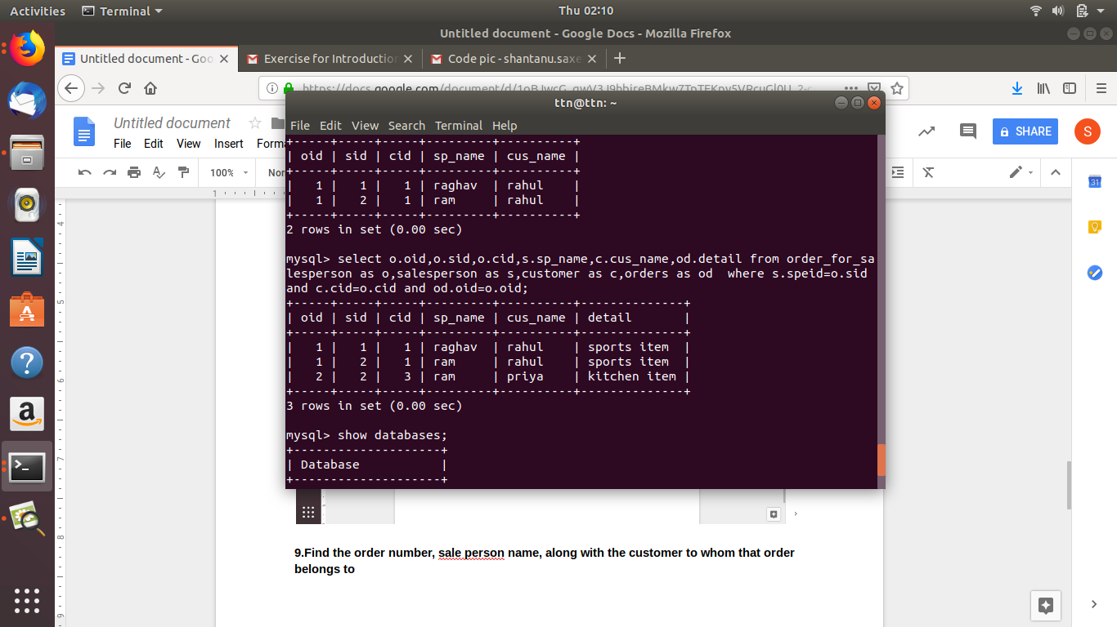

**Select o.oid,o.sid,o.cid,s.sp_name,c.cus_name,od.detail from order_for_salesperson as o,salesperson as s,customer as c,orders as od where s.speid=o.sid and c.cid=o.cid and od.oid=o.oid;**